

Net-zero Pathways

Social Accounting Matrix (SAM)

2019

DRAFT

APRIL 2021

# Contents

Contents 2

Introduction 3

Structure of the SAM 3

Methodology used 6

Energy in the SAM 8

Coke, Petroleum and Nuclear Fuels 9

Input Structure 10

Output structure in SAM 15

Contribution to employment and other concepts 18

Electricity and gas 18

Input Structure 21

Output structure in SAM 27

Contribution to employment and other concepts 28

Summary 29

Appendix A – List of Industries and Commodities, and Labour Categories 31

Industries 31

List of labour categories 32

Appendix B – Data sources used 33

Appendix C – SIC classification 34

SIC: Extraction of crude petroleum and natural gas [QSIC 221] 34

SIC: Other mining and quarrying [QSIC 25-29] 34

SIC: Manufacture of Coke Oven Products [QSIC 331] 34

Petroleum refineries or synthesisers [QSIC 332] 34

Nuclear fuels [QSIC 333] 34

Electricity [QSIC 411] 35

Gas [QSIC 412] 35

# Introduction

The structure of the economy at the start of the net-zero pathway adjustments is captured using a Social Accounting Matrix (SAM). The SAM provides a point-in-time view of the economy by organizing economic and socio-economic data for South Africa in a comprehensive and systematic format. The 2019 Net-zero Pathway SAM then provides the foundation for the socio-economic modelling of the net-zero pathways. The Net-zero Pathway SAM captures the full economy but focuses on energy production and consumption in South Africa. For this purpose, the SAM contains more detail on the petroleum and electricity sectors, the providers of energy, but also on other sectors such as agriculture, mining, manufacturing and transport, sectors that are important users of energy.

# Structure of the SAM

The United Nations’ (2008)[1] System of National Accounts (SNA) defines a SAM as a presentation of the SNA in a matrix that elaborates the linkages between the supply and use tables and institutional sector accounts. The SAM represents the flow of transactions in the economy and is another way of stating the circular flow in an economy. The circular flow results from commodities produced by producers through their activities with the available production factors. A SAM therefore contains data on production activities, intermediate inputs, primary factors including labour and capital, commodities, households and other institutions like enterprises, the government and the rest of the world. A SAM portrays the system of inter-industry linkages in an economy. For example, intermediate inputs purchased by one industry at the same time represents sales of another industry (Devarajan et al,1994:3-2). Technically, a SAM is a square matrix within which each account is represented by a row and a column (Löfgren et al,2001:3)[2]. The columns represent expenditures, and the rows incomes. The double-accounting principle ensures that the totals in the rows will equal the totals in the columns, A SAM usually focuses on the real side of the economy. A SAM is static and gives an account of a country’s economic structure at one point in time (Table 2 Theoretical content of the SAM).

The Net-zero Pathway SAM contains 104 industries and commodities per SIC-3 classification. See the list of industries and commodities included in the SAM in Appendix A. The detailed petroleum and energy industries and commodities included in the SAM are:

Table 1 Petroleum and Electricity in the SAM

|  |  |
| --- | --- |
| **Industries and Commodities** | |
| **Coke, Petroleum and Nuclear Fuels [QSIC 33]** | **Electricity and Gas [QSIC 41]** |
| Coke [QSIC 331] | Electricity from coal generation [QSIC 411] |
| Conventional refineries (OTL) [QSIC 3321] | Electricity from gas [QSIC 411] |
| Conventional synfuels (CTL and GTL) [QSIC 3322-3323] | Nuclear energy [QSIC 411] |
| Biofuels [QSIC 3324] | Wind energy [QSIC 411] |
| Green synfuels (Green H2) [QSIC 3325,3329] | Solar energy [QSIC 411] |
| Nuclear fuel [QSIC 333] | Hydro energy [QSIC 411] |
|  | Gas [QSIC 412] |

The SAM also includes:

* Production factors capital and labour; labour is further disaggregated by sector and skill level (see Appendix A for a list of labour types included).
* Households are disaggregated by deciles with the highest decile further disaggregated to provide for 13 household groups.
* The other institutions, apart from households included in the SAM are firms, the government and the rest of the world.
* The SAM also include detailed tax information and includes taxes and subsidies on production, value-added tax, custom duties, fuel levy, excise duties, other taxes on products and subsidies on products, personal income tax and company taxes.

Underlying physical capital values and employment numbers are also provided with the SAMs.

Table 2 Theoretical content of the SAM

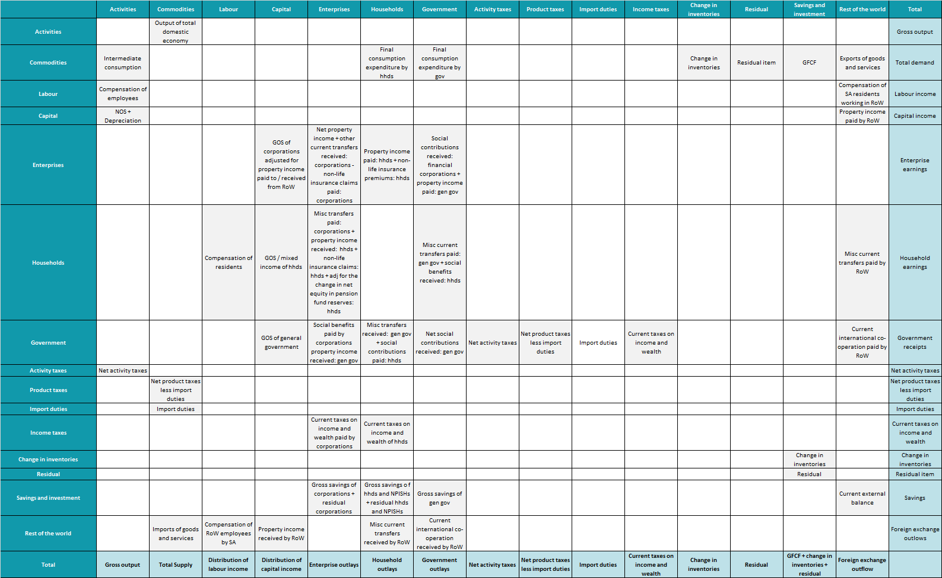

# Methodology used

The construction of the Net-zero Pathway SAM for 2019 entails the construction of the following tables:

The process of constructing a SAM starts with the construction of Supply-and-Use Tables (SUTs) at Market Prices. An SUT at market prices includes the use of commodities at market prices by industries, households and for other purposes such as exports, as well as the supply of commodities through domestic production and imports. An SUT at market prices also includes trade and transport margins as well as product taxes and subsidies. (SNA, 2008). Stats SA produces Supply-and-Use tables on an annual basis and are published as part of the GDP publication. The Stats SA SUTs do not always follow the same level of industry/commodity disaggregation. Quantec uses the Stats SA SUT framework as well as other data published by Stats SA to generate SUTs in timeseries format for 91 industries and commodities. The SUTs are consistent with national accounts data. These tables are used as underlying tables to develop the Net-zero Pathway SAM for 2019. The SUT at market prices were expanded to include detailed energy accounts; it was expanded to include 102 industries and 94 commodities. Additional data sources used to expand energy in the SUT/SAM, include:

* Annual Financial Survey, 2018. Stats SA.
* Eskom Annual Reports (2010 – 2020), including Annual Financial Statements, Integrated Reports and Sustainable reports.
* Unpublished employment and labour remuneration information for Eskom for 2020/19.
* Consolidated Aggregated Historical Energy Balances. 2017. Department of Energy.
* Sasol Annual Reports for 2020, including the Annual Financial Statement and Integrated Report.
* Unpublished employment figures for Sasol for 2020.
* PetroSA Annual Report for 2019.
* Trade statistics from SARS. 2018, 2019 and 2020.
* Supply and Use Tables from Stats SA for 2015.
* Petroleum industry information from SAPIA, various years.

|  |
| --- |
| **Sasol Limited**  Sasol Ltd is a global chemical and energy company. The company source, manufacture and market chemical products globally and supply energy products in Southern Africa. The company has mining operations in Europe and Asia, Australasia and the Middle East, mining exploration and production in the rest of Africa, Europe and North America, energy operation in South Africa, the rest of Africa and Europe, and base and performance chemical operations in South Africa, the rest of Africa, Europe, North and South America, Asia, Australasia and the Middle East. The company’s operations in South Africa during 2020 represented 45% of the company’s turnover and within South Africa its energy operations represented 74% of its revenue generated in South Africa. Sasol’s energy operations mainly utilise conventional synfuel (coal-to-liquid (CTL) and gas-to-liquid (GTL)) processes. Its oil-to-liquid (OTL) refining operations is as a result of a share Sasol owns in Natref (owns 64% of equity and generated revenue of R2 157 million in 2020). Sasol source feedstock from mining in Secunda and Sasolburg, gas from Mozambique and oil from Gabon. The company employs 31 000 employees globally of which 83% is based in South Africa.  (Sasol, Integrated Report, Annual Financial Statements and Sustainability Report for 2020).  Sasol’s energy operations are classified according to Stats SA’s SIC classification as the manufacture of refined petroleum products (SIC 332).  Sasol’s performance chemicals produced includes the production of organics, wax, and other advanced materials, while the base chemicals produced includes polymers, solvents, explosives, and fertilisers. Sasol’s performance and base chemicals produced are classified according to Stats SA’s SIC classification as the manufacture of chemicals and chemical products (SIC 334, 335 and 336).  (Stats SA SIC Classification System 5th Ed.)  **PetroSA SOC Limited**  The operations of PetroSA focus on the exploration and production of oil and natural gas resources locally and internationally, the acquisition of upstream petroleum ventures, the production of synthetic fuels from offshore gas (GTL refining), the development of domestic refining capacity, and the marketing and trading of oil and petroleum products. PetroSA has joint ventures globally, with its GTL refinery situated in Mossel Bay in South Africa. The company employed 1 424 fixed term employees and 176 short-term contract employees at the end of March 2019.  (PetroSA, Integrated Report, 2019).  PetroSA’s refining operations are classified according to Stats SA’s SIC classification as the manufacture of refined petroleum products (SIC 332), while the company’s natural gas and oil trading are classified as mining activities.  (Stats SA SIC Classification System 5th Ed.) |

National Accounts data are used to construct a macro-SAM. The SUT at market prices, are combined with the macro-SAM to generate a SAM. Detailed data for households and labour accounts are obtained from population censuses, household income and expenditure surveys, and labour force surveys. Thus, the compilation of a SAM is very data intensive and various data sources are used in the construction of the SAM, including national accounts data, supply and use tables, population censuses, labour force surveys, household surveys, income and expenditure surveys and many more. Additional data was required to provide the energy focus in the Net-zero Pathway SAM for 2019. The list of data sources used are included in Appendix B.

|  |
| --- |
| **Eskom Holdings SOC Ltd**  Eskom is South Africa’s largest producer of electricity and generates about 90% of South Africa’s electricity. In 2020 Eskom generated 214 968 GWh. Eskom’s electricity generation was mostly generated by coal-fired stations (194 357 GWh), followed by nuclear power (13 252 GWh), the rest was generated using hydro generation, gas generation (OCGTS) and wind farming. A further 11 958 GWh of electricity was produced by independent power producers (IPPs) and 8 568 GWh of electricity was imported from the rest of Africa.  In 2020, Eskom generated revenue of R199.5 billion, EBITDA of R37 billion, paid R33 billion to its 44 772 employees and invested R23.4 billion.  (Eskom, Integrated Report, 2020).  All Eskom’s activities are classified as SIC 411 or electricity generation, transformation and distribution activities.  (Stats SA SIC Classification System 5th Ed.) |

# Energy in the SAM

The initial SUT/SAM framework does not have detailed industries and/or commodities for the energy accounts by generation type. In the initial SUT/SAM the petroleum industry forms part of the Coke, Petroleum and Nuclear Fuels (QSIC [331-333]) industry and the electricity industry forms part of the Electricity and Gas industry (QSIC [41]).

## Coke, Petroleum and Nuclear Fuels

The Coke, Petroleum and Nuclear Fuels (QSIC [331-333]) industry were further disaggregated into the following sub-industries:

* Coke (QSIC [331])
* Conventional refineries (OTL) (QSIC 3321)
* Conventional synfuels (CTL and GTL) (QSIC 3322-3323)
* Biofuels (QSIC 3324)[3]
* Green synfuels (Green H2) (QSIC 3325, 3329)[4]
* Nuclear fuels (QSIC [333])

Stats SA’s AFS data provides sufficient information to allow the split of the Coke, Petroleum and Nuclear Fuels industry into three sub-industries, namely Coke (QSIC [331]), Petroleum (QSIC [332]) and Nuclear Fuels (QSIC [333]). The petroleum (QSIC [332]) sub-industry is further disaggregated by process type.

There are four conventional refinery operators in South Africa, including Natref which is jointly owned by Sasol and Total, Astron, Sapref (Shell and BP) and Engen. Sasol uses both conventional synfuel (CTL and GTL) refining processes, while PetroSA uses GTL refining. The biofuels and green synfuels processes do not currently exist in South Africa but are part of the Net-zero Pathway adjustments and are therefore included in this framework. Publicly available financial information for Sasol and PetroSA were used to determine the contribution of conventional synfuels. Conventional refineries were then mostly treated as a residual.

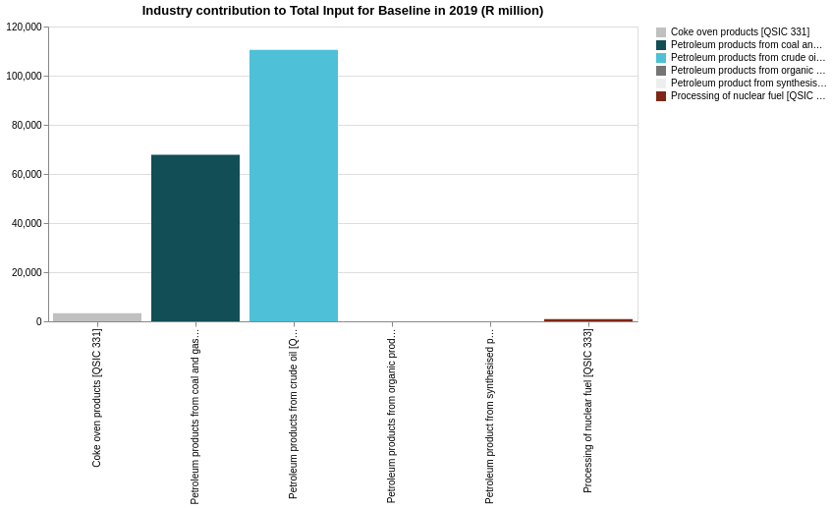

The Petroleum products from crude oil [QSIC 3321] industry had the highest total input of all the industries in the Coke petroleum products and nuclear fuel [QSIC 331-333] industry. The Petroleum products from crude oil [QSIC 3321] industry contributed 60.54% to total input of the Coke petroleum products and nuclear fuel [QSIC 331-333] industry, and 1.14% to South African total input.

The other industries' contributions to total input were Petroleum products from coal and gas [QSIC 3322 and 3323] 37.15%, Coke oven products [QSIC 331] 1.81%, Processing of nuclear fuel [QSIC 333] 0.50%, Petroleum product from synthesised products nec [QSIC 3329] 0.00%, and Petroleum products from organic products [QSIC 3324] 0.00%.

### Input Structure

The input structure of the industries consists of all the goods used in the process of producing outputs, all labour remuneration paid, as well as the gross operating surplus of the industry. In National Accounts, the Gross Operating Surplus is a balancing item in the generation of income account and include all factor returns not already included in labour remuneration such as interest paid and profit. It is a gross value as no allowance for consumption of fixed assets (or depreciation) are made. Other inputs, although usually relatively small, is production taxes net of subsidies.

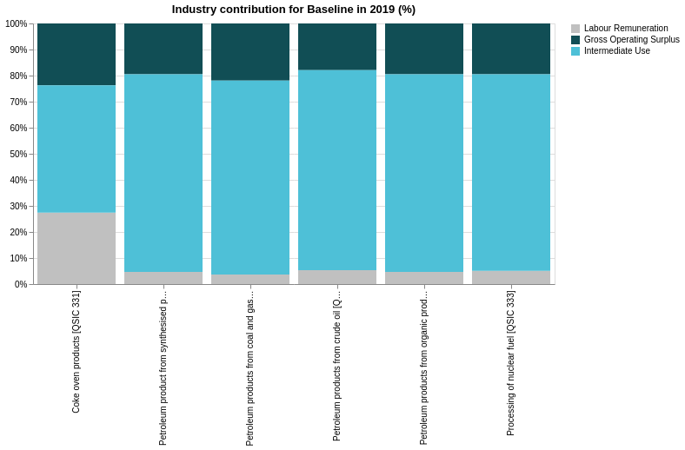

* The Petroleum products from crude oil [QSIC 3321] industry paid the most in labour remuneration of all the industries in the Coke petroleum products and nuclear fuel [QSIC 331-333] industry. The Petroleum products from crude oil [QSIC 3321] industry contributed 63.25% to labour remuneration of the Coke petroleum products and nuclear fuel [QSIC 331-333] industry, and 0.24% to South African labour remuneration. The other industries' contributions to labour remuneration were Petroleum products from coal and gas [QSIC 3322 and 3323] 26.52%, Coke oven products [QSIC 331] 9.73%, Processing of nuclear fuel [QSIC 333] 0.50%, Petroleum products from organic products [QSIC 3324] 0.00%, and Petroleum product from synthesised products nec [QSIC 3329] 0.00%.
* The Petroleum products from crude oil [QSIC 3321] industry had the highest gross operating surplus of all the industries in the Coke petroleum products and nuclear fuel [QSIC 331-333] industry. The Petroleum products from crude oil [QSIC 3321] industry contributed 55.58% to gross operating surplus of the Coke petroleum products and nuclear fuel [QSIC 331-333] industry, and 0.98% to South African gross operating surplus. The other industries' contributions to gross operating surplus were Petroleum products from coal and gas [QSIC 3322 and 3323] 41.71%, Coke oven products [QSIC 331] 2.21%, Processing of nuclear fuel [QSIC 333] 0.50%, Petroleum product from synthesised products nec [QSIC 3329] 0.00%, and Petroleum products from organic products [QSIC 3324] 0.00%.
* The Petroleum products from crude oil [QSIC 3321] industry had the highest intermediate use of all the industries in the Coke petroleum products and nuclear fuel [QSIC 331-333] industry. The Petroleum products from crude oil [QSIC 3321] industry contributed 61.63% to intermediate use of the Coke petroleum products and nuclear fuel [QSIC 331-333] industry, and 1.62% to South African intermediate use. The other industries' contributions to intermediate use were Petroleum products from coal and gas [QSIC 3322 and 3323] 36.69%, Coke oven products [QSIC 331] 1.18%, Processing of nuclear fuel [QSIC 333] 0.50%, Petroleum product from synthesised products nec [QSIC 3329] 0.00%, and Petroleum products from organic products [QSIC 3324] 0.00%.

The total input of the Petroleum products from crude oil [QSIC 3321] industry was R110,472.41 million in 2019, representing 60.54% of the Coke petroleum products and nuclear fuel [QSIC 331-333] industry's total input. The total input of the Petroleum products from crude oil [QSIC 3321] industry consisted of value-added 23.15% and intermediate use 76.27%, the rest was made up from production taxes net of production subsidies. The value-added components of the Petroleum products from crude oil [QSIC 3321] industry consisted of labour remuneration 5.31% and gross operating surplus 17.84%, the Petroleum products from crude oil [QSIC 3321] industry was relatively capital intensive.

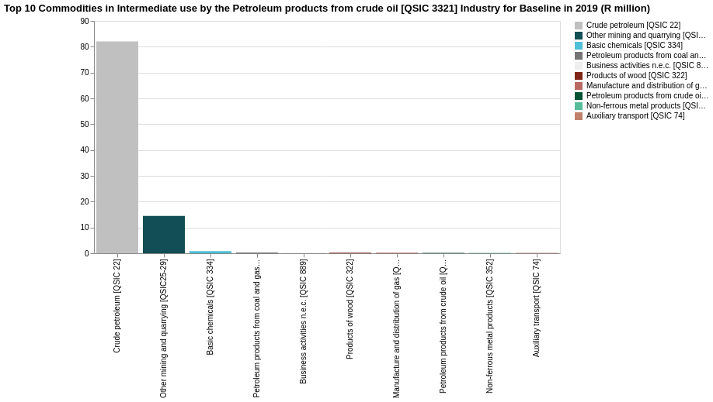

The value of intermediate use of the Petroleum products from crude oil [QSIC 3321] industry was R84,254.76 million. The commodity used most in this industry was Crude petroleum [QSIC 22] and represented 82.03% of its own intermediate use. Other commodities that were included in the top 5 commodities were Other mining and quarrying [QSIC25-29] (14.48%), Basic chemicals [QSIC 334] (0.86%), Petroleum products from coal and gas [QSIC 3322 and 3323] (0.29%), and Business activities n.e.c. [QSIC 889] (0.26%).

The total input of the Petroleum products from coal and gas [QSIC 3322 and 3323] industry was R67,799.50 million in 2019, representing 37.15% of the Coke petroleum products and nuclear fuel [QSIC 331-333] industry's total input. The total input of the Petroleum products from coal and gas [QSIC 3322 and 3323] industry consisted of value-added 25.44% and intermediate use 73.98%, the rest was made up from production taxes net of production subsidies. The value-added components of the Petroleum products from coal and gas [QSIC 3322 and 3323] industry consisted of labour remuneration 3.63% and gross operating surplus 21.81%, the Petroleum products from coal and gas [QSIC 3322 and 3323] industry was relatively capital intensive.

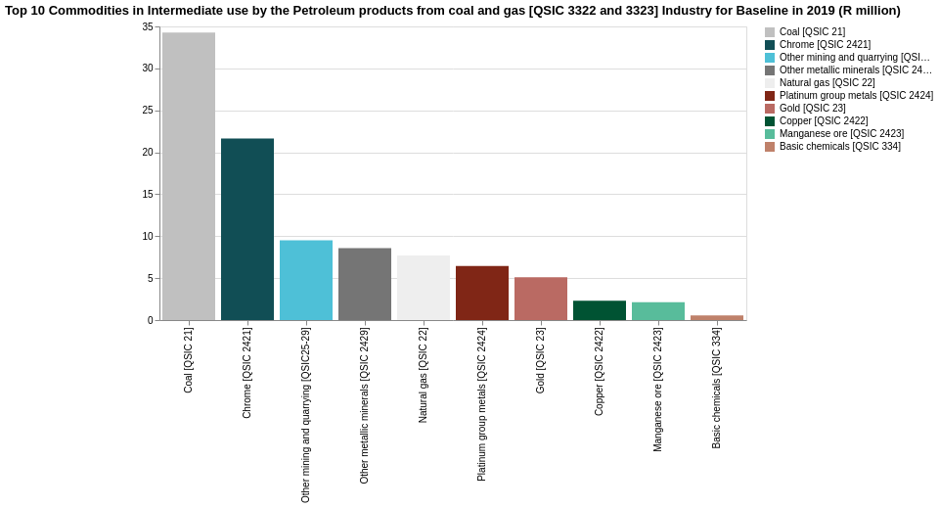

The value of intermediate use of the Petroleum products from coal and gas [QSIC 3322 and 3323] industry was R50,157.75 million. The commodity used most in this industry was Coal [QSIC 21] and represented 34.28% of its own intermediate use. Other commodities that were included in the top 5 commodities were Chrome [QSIC 2421] (21.63%), Other mining and quarrying [QSIC25-29] (9.52%), Other metallic minerals [QSIC 2429] (8.59%), and Natural gas [QSIC 22] (7.70%).

The other industries:

* The total input of the Coke oven products [QSIC 331] industry was R3,299.81 million in 2019, representing 1.81% of the Coke petroleum products and nuclear fuel [QSIC 331-333] industry's total input. The total input of the Coke oven products [QSIC 331] industry consisted of value-added 51.10% and intermediate use 48.74%, the rest was made up from production taxes net of production subsidies. The value-added components of the Coke oven products [QSIC 331] industry consisted of labour remuneration 27.38% and gross operating surplus 23.72%, the Coke oven products [QSIC 331] industry was relatively labour intensive. The value of intermediate use of the Coke oven products [QSIC 331] industry was R1,608.27 million. The commodity used most in this industry was Basic chemicals [QSIC 334] and represented 19.86% of its own intermediate use. Other commodities that were included in the top 5 commodities were Coal [QSIC 21] (12.79%), Iron ore [QSIC 241] (6.89%), Petroleum products from coal and gas [QSIC 3322 and 3323] (6.73%), and Business activities n.e.c. [QSIC 889] (6.10%).
* The total input of the Processing of nuclear fuel [QSIC 333] industry was R909.41 million in 2019, representing 0.50% of the Coke petroleum products and nuclear fuel [QSIC 331-333] industry's total input. The total input of the Processing of nuclear fuel [QSIC 333] industry consisted of value-added 24.52% and intermediate use 74.91%, the rest was made up from production taxes net of production subsidies. The value-added components of the Processing of nuclear fuel [QSIC 333] industry consisted of labour remuneration 5.09% and gross operating surplus 19.43%, the Processing of nuclear fuel [QSIC 333] industry was relatively capital intensive. The value of intermediate use of the Processing of nuclear fuel [QSIC 333] industry was R681.27 million. The commodity used most in this industry was Chrome [QSIC 2421] and represented 39.79% of its own intermediate use. Other commodities that were included in the top 5 commodities were Other metallic minerals [QSIC 2429] (15.79%), Platinum group metals [QSIC 2424] (11.86%), Gold [QSIC 23] (9.40%), and Copper [QSIC 2422] (4.24%).

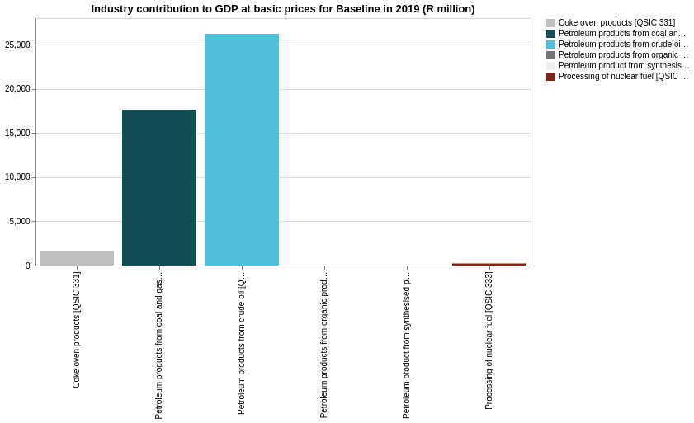

GDP at basic prices includes the value-added components, labour remuneration and gross operating surplus as well as production taxes net of production subsidies.

The Petroleum products from crude oil [QSIC 3321] industry contributed the most GDP at basic prices of all the industries in the Coke petroleum products and nuclear fuel [QSIC 331-333] industry. The Petroleum products from crude oil [QSIC 3321] industry contributed 57.27% to GDP at basic prices of the Coke petroleum products and nuclear fuel [QSIC 331-333] industry, and 0.58% to South African GDP at basic prices. The other industries' contributions to GDP at basic prices were Petroleum products from coal and gas [QSIC 3322 and 3323] 38.54%, Coke oven products [QSIC 331] 3.70%, Processing of nuclear fuel [QSIC 333] 0.50%, Petroleum product from synthesised products nec [QSIC 3329] 0.00%, and Petroleum products from organic products [QSIC 3324] 0.00%.

### Output structure in SAM

The commodities produced by the coke, petroleum and nuclear fuel industry is further disaggregated into the commodities Coke [QSIC 331], Petroleum products [QSIC 332] and Nuclear fuel products [QSIC 333]. The output of the generation industries Petroleum products from crude oil [QSIC 3321] and Petroleum products from coal and gas [QSIC 3322 and 3323] flow into a single commodity, namely Petroleum products [QSIC 332}.

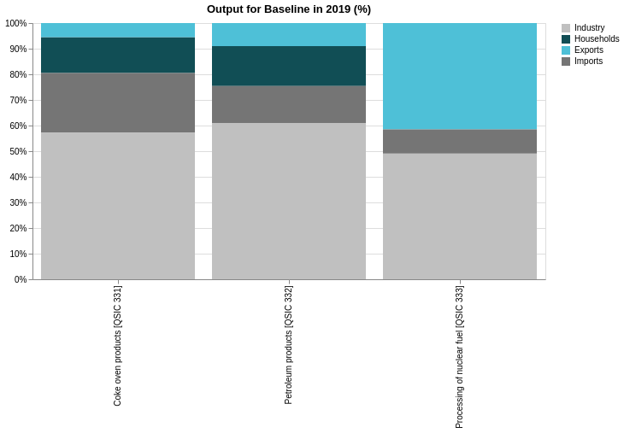

The Petroleum products [QSIC 332] commodity sold most to industry compared to all the commodities in the Coke petroleum products and nuclear fuel [QSIC 331-333] commodity. The Petroleum products [QSIC 332] commodity represented 97.93% of industry sales of the Coke petroleum products and nuclear fuel [QSIC 331-333] commodity, and 5.96% of South African industry sales. The other commodities' contributions to industry were Coke oven products [QSIC 331] 1.76%, and Processing of nuclear fuel [QSIC 333] 0.30%.

The Petroleum products [QSIC 332] commodity sold most to households compared to all the commodities in the Coke petroleum products and nuclear fuel [QSIC 331-333] commodity. The Petroleum products [QSIC 332] commodity represented 98.31% of households sales of the Coke petroleum products and nuclear fuel [QSIC 331-333] commodity, and 2.58% of South African households sales. The other commodities' contributions to households were and Coke oven products [QSIC 331] 1.69%.

The Petroleum products [QSIC 332] commodity sold most to exports compared to all the commodities in the Coke petroleum products and nuclear fuel [QSIC 331-333] commodity. The Petroleum products [QSIC 332] commodity represented 97.13% of exports sales of the Coke petroleum products and nuclear fuel [QSIC 331-333] commodity, and 3.03% of South African exports sales. The other commodities' contributions to exports were Processing of nuclear fuel [QSIC 333] 1.73%, and Coke oven products [QSIC 331] 1.14%.

The Petroleum products [QSIC 332] commodity the highest amount of to imports compared to all the commodities in the Coke petroleum products and nuclear fuel [QSIC 331-333] commodity. The Petroleum products [QSIC 332] commodity represented 96.78% of imports sales of the Coke petroleum products and nuclear fuel [QSIC 331-333] commodity, and 4.91% of South African imports sales. The other commodities' contributions to imports were Coke oven products [QSIC 331] 2.98%, and Processing of nuclear fuel [QSIC 333] 0.25%.

The Petroleum products [QSIC 332] commodity contributed the most to total supply compared to all the commodities in the Coke petroleum products and nuclear fuel [QSIC 331-333] commodity. The Petroleum products [QSIC 332] commodity represented 97.92% of total supply sales of the Coke petroleum products and nuclear fuel [QSIC 331-333] commodity, and 3.36% of South African total supply sales. The other commodities' contributions to total supply were Coke oven products [QSIC 331] 1.68%, and Processing of nuclear fuel [QSIC 333] 0.40%.

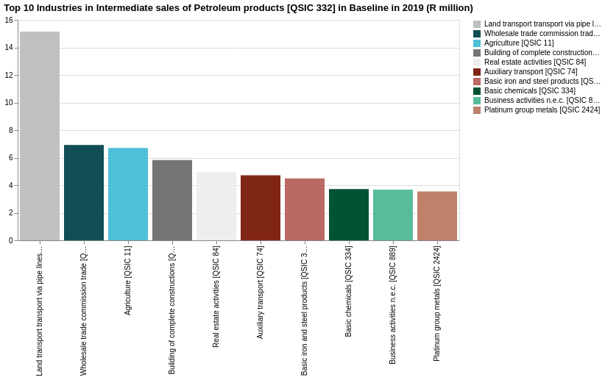

The output of the Petroleum products [QSIC 332] commodity was sold to industry (97.93%), households (18.17%), and exports (10.55%). 16.81% of output was imported.

The value of intermediate sales of the Petroleum products [QSIC 332] commodity was R45,888.22 million. Output of this commodity was sold mostly to the Land transport transport via pipe lines [QSIC 71] industry and represented 15.15% of its total intermediate sales. Other industries that were included in the top 5 were Wholesale trade commission trade [QSIC 61] (6.92%), Agriculture [QSIC 11] (6.71%), Building of complete constructions [QSIC 502] (5.82%), and Real estate activities [QSIC 84] (4.96%).

The other industries:

* The output of the Coke oven products [QSIC 331] commodity was sold to industry (1.76%), households (18.17%), and exports (7.20%). 30.11% of output was imported. The value of intermediate sales of the Coke oven products [QSIC 331] commodity was R538.47 million. Output of this commodity was sold mostly to the Electricity from coal [QSIC 41111] industry and represented 29.99% of its total intermediate sales. Other industries that were included in the top 5 were Basic iron and steel products [QSIC 351] (28.98%), Basic chemicals [QSIC 334] (23.94%), Other chemical products [QSIC 335-336] (13.12%), and Manufacture and distribution of gas [QSIC 412] (1.76%).
* The output of the Processing of nuclear fuel [QSIC 333] commodity was sold to industry (0.30%), and exports (45.84%). 10.43% of output was imported. The value of intermediate sales of the Processing of nuclear fuel [QSIC 333] commodity was R185.97 million. Output of this commodity was sold mostly to the Electricity from nuclear power [QSIC 41111] industry and represented 100.00% of its total intermediate sales.

### Contribution to employment and other concepts

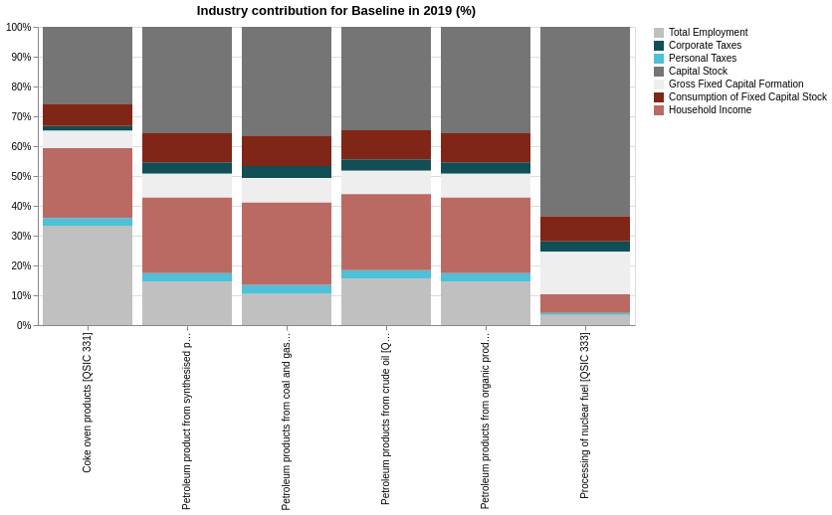

The Petroleum products from crude oil [QSIC 3321] industry contributed the most to to total employment compared to all the industries in the Coke petroleum products and nuclear fuel [QSIC 331-333] industry. The Petroleum products from crude oil [QSIC 3321] industry contributed 63.25% to total employment of the Coke petroleum products and nuclear fuel [QSIC 331-333] industry, and 0.11% to South African total employment.

The other industries' contributions to total employment were Petroleum products from coal and gas [QSIC 3322 and 3323] 26.52%, Coke oven products [QSIC 331] 9.73%, Processing of nuclear fuel [QSIC 333] 0.50%, Petroleum product from synthesised products nec [QSIC 3329] 0.00%, and Petroleum products from organic products [QSIC 3324] 0.00%.

## Electricity and gas

Stats SA’s AFS data provides sufficient information to allow the split of the Gas and Electricity industry (QSIC [41]) into two sub-industries, namely Electricity (QSIC [411]) and Gas (QSIC [412]). The Electricity sub-industry, in turn, is then further disaggregated. First by (1) electricity generation and (2) electricity transmission and distribution. The electricity generation sub-industry is then lastly further disaggregated by generation process. The electricity and gas [QSIC 4] industry was first divided into electricity [QSIC 41] and gas [QSIC 42], the electricity [QSIC 41] industry was then divided into electricity generation [QSIC 411] and electricity transmission and distribution [QSIC 412 and 413]. The Electricity generation [QSIC 411] was then further sub-divided by generation process.

The following sub-industries and generation processes are included in the SAM:

* Electricity from coal (QSIC [41111])
* Electricity from OCGTs (QSIC [41111])
* Electricity from nuclear (QSIC [41111])
* Electricity from wind energy (QSIC [41111])
* Electricity from solar energy (QSIC [41111])
* Electricity from hydro energy (QSIC [41111])
* Electricity from gas (QSIC [41111])[5]
* Electricity transmission and distribution (QSIC [41112])
* Gas (QSIC [412])

Publicly available financial information for Eskom was used to split electricity generation by type. In 2020/2019, Eskom generated 214 968 GWh electricity, purchased 11 958 GWh electricity from Independent Power Producers (IPPs), and imported 8 568 GWh from neighbouring countries. Electricity generation data and unit price costs from Eskom were used to split electricity generation by process. The per unit cost of electricity from OCGTs is the highest for all generation types.

Table 3 Electricity generation by generation process

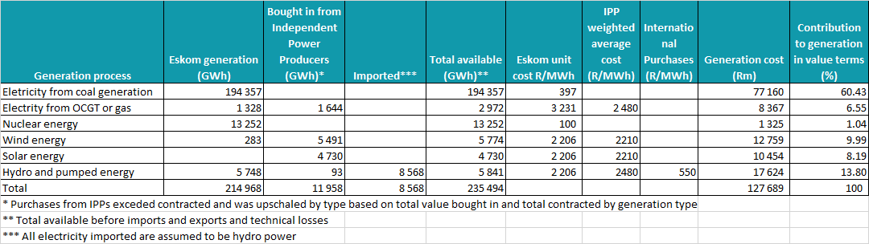

The energy balances from the Department of Energy were used to identify the most important resource used in the production of electricity by generation type and also to identify the most significant users of electricity in South Africa.

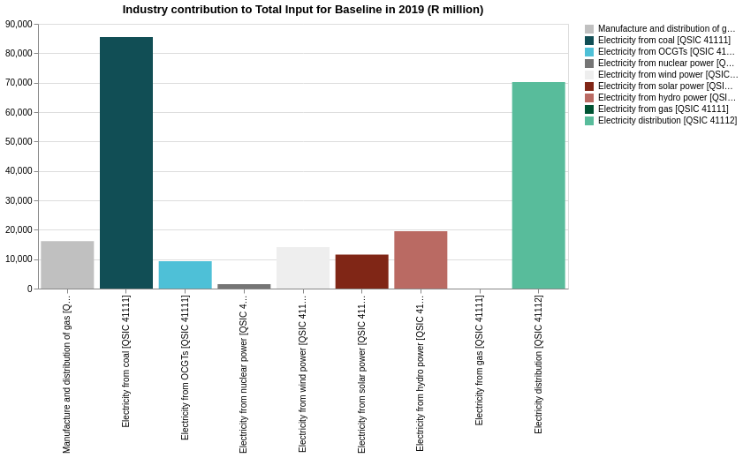

The Electricity from coal [QSIC 41111] industry had the highest total input of all the industries in the Electricity and gas [QSIC 41] industry. The Electricity from coal [QSIC 41111] industry contributed 37.53% to total input of the Electricity and gas [QSIC 41] industry, and 0.88% to South African total input. The other industries' contributions to total input were Electricity distribution [QSIC 41112] 30.81%, Electricity from hydro power [QSIC 41111] 8.57%, Manufacture and distribution of gas [QSIC 412] 7.09%, Electricity from wind power [QSIC 41111] 6.20%, Electricity from solar power [QSIC 41111] 5.09%, Electricity from OCGTs [QSIC 41111] 4.07%, Electricity from nuclear power [QSIC 41111] 0.65%, and Electricity from gas [QSIC 41111] 0.00%.

### Input Structure

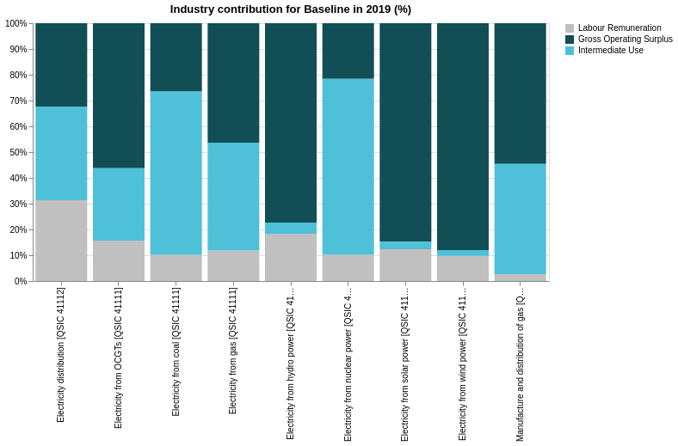

* The Electricity distribution [QSIC 41112] industry paid the most in labour remuneration of all the industries in the Electricity and gas [QSIC 41] industry. The Electricity distribution [QSIC 41112] industry contributed 56.15% to labour remuneration of the Electricity and gas [QSIC 41] industry, and 0.91% to South African labour remuneration. The other industries' contributions to labour remuneration were Electricity from coal [QSIC 41111] 22.29%, Electricity from hydro power [QSIC 41111] 9.16%, Electricity from OCGTs [QSIC 41111] 3.72%, Electricity from solar power [QSIC 41111] 3.66%, Electricity from wind power [QSIC 41111] 3.52%, Manufacture and distribution of gas [QSIC 412] 1.11%, Electricity from nuclear power [QSIC 41111] 0.38%, and Electricity from gas [QSIC 41111] 0.00%.
* The Electricity distribution [QSIC 41112] industry had the highest gross operating surplus of all the industries in the Electricity and gas [QSIC 41] industry. The Electricity distribution [QSIC 41112] industry contributed 23.39% to gross operating surplus of the Electricity and gas [QSIC 41] industry, and 1.13% to South African gross operating surplus. The other industries' contributions to gross operating surplus were Electricity from coal [QSIC 41111] 23.32%, Electricity from hydro power [QSIC 41111] 15.56%, Electricity from wind power [QSIC 41111] 12.81%, Electricity from solar power [QSIC 41111] 10.12%, Manufacture and distribution of gas [QSIC 412] 9.10%, Electricity from OCGTs [QSIC 41111] 5.38%, Electricity from nuclear power [QSIC 41111] 0.33%, and Electricity from gas [QSIC 41111] 0.00%.
* The Electricity from coal [QSIC 41111] industry had the highest intermediate use of all the industries in the Electricity and gas [QSIC 41] industry. The Electricity from coal [QSIC 41111] industry contributed 59.05% to intermediate use of the Electricity and gas [QSIC 41] industry, and 1.04% to South African intermediate use. The other industries' contributions to intermediate use were Electricity distribution [QSIC 41112] 27.83%, Manufacture and distribution of gas [QSIC 412] 7.55%, Electricity from OCGTs [QSIC 41111] 2.83%, Electricity from nuclear power [QSIC 41111] 1.09%, Electricity from hydro power [QSIC 41111] 0.93%, Electricity from solar power [QSIC 41111] 0.37%, Electricity from wind power [QSIC 41111] 0.36%, and Electricity from gas [QSIC 41111] 0.00%.

The total input of the Electricity from coal [QSIC 41111] industry was R85,473.14 million in 2019, representing 37.53% of the Electricity and gas [QSIC 41] industry's total input. The total input of the Electricity from coal [QSIC 41111] industry consisted of value-added 36.60% and intermediate use 63.24%, the rest was made up from production taxes net of production subsidies. The value-added components of the Electricity from coal [QSIC 41111] industry consisted of labour remuneration 10.18% and gross operating surplus 26.41%, the Electricity from coal [QSIC 41111] industry was relatively capital intensive.

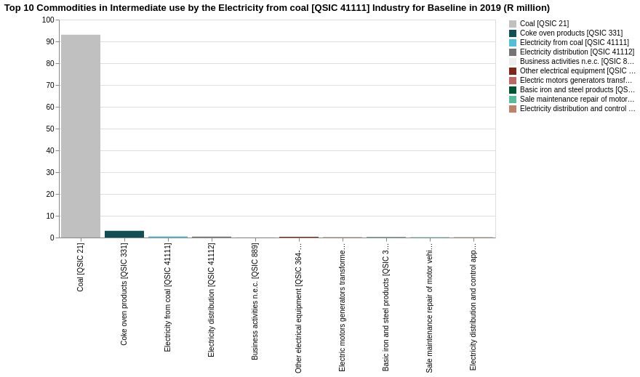

The value of intermediate use of the Electricity from coal [QSIC 41111] industry was R54,049.37 million. The commodity used most in this industry was Coal [QSIC 21] and represented 93.09% of its own intermediate use. Other commodities that were included in the top 5 commodities were Coke oven products [QSIC 331] (3.10%), Electricity from coal [QSIC 41111] (0.46%), Electricity distribution [QSIC 41112] (0.38%), and Business activities n.e.c. [QSIC 889] (0.33%).

The other generation industries:

* The total input of the Electricity from OCGTs [QSIC 41111] industry was R9,264.43 million in 2019, representing 4.07% of the Electricity and gas [QSIC 41] industry's total input. The total input of the Electricity from OCGTs [QSIC 41111] industry consisted of value-added 71.86% and intermediate use 27.97%, the rest was made up from production taxes net of production subsidies. The value-added components of the Electricity from OCGTs [QSIC 41111] industry consisted of labour remuneration 15.68% and gross operating surplus 56.18%, the Electricity from OCGTs [QSIC 41111] industry was relatively capital intensive. The value of intermediate use of the Electricity from OCGTs [QSIC 41111] industry was R2,591.38 million. The commodity used most in this industry was Petroleum products from coal and gas [QSIC 3322 and 3323] and represented 53.74% of its own intermediate use. Other commodities that were included in the top 5 commodities were Petroleum products from crude oil [QSIC 3321] (32.98%), Electricity from coal [QSIC 41111] (1.60%), Electricity distribution [QSIC 41112] (1.31%), and Business activities n.e.c. [QSIC 889] (1.15%).
* The total input of the Electricity from hydro power [QSIC 41111] industry was R19,518.96 million in 2019, representing 8.57% of the Electricity and gas [QSIC 41] industry's total input. The total input of the Electricity from hydro power [QSIC 41111] industry consisted of value-added 95.49% and intermediate use 4.34%, the rest was made up from production taxes net of production subsidies. The value-added components of the Electricity from hydro power [QSIC 41111] industry consisted of labour remuneration 18.32% and gross operating surplus 77.17%, the Electricity from hydro power [QSIC 41111] industry was relatively capital intensive. The value of intermediate use of the Electricity from hydro power [QSIC 41111] industry was R846.83 million. The commodity used most in this industry was Electricity from coal [QSIC 41111] and represented 12.05% of its own intermediate use. Other commodities that were included in the top 5 commodities were Electricity distribution [QSIC 41112] (9.89%), Business activities n.e.c. [QSIC 889] (8.68%), Other electrical equipment [QSIC 364-366] (8.38%), and Electric motors generators transformers [QSIC 361] (4.99%).
* The total input of the Electricity from solar power [QSIC 41111] industry was R11,584.08 million in 2019, representing 5.09% of the Electricity and gas [QSIC 41] industry's total input. The total input of the Electricity from solar power [QSIC 41111] industry consisted of value-added 96.91% and intermediate use 2.92%, the rest was made up from production taxes net of production subsidies. The value-added components of the Electricity from solar power [QSIC 41111] industry consisted of labour remuneration 12.32% and gross operating surplus 84.59%, the Electricity from solar power [QSIC 41111] industry was relatively capital intensive. The value of intermediate use of the Electricity from solar power [QSIC 41111] industry was R337.94 million. The commodity used most in this industry was Electricity from coal [QSIC 41111] and represented 12.05% of its own intermediate use. Other commodities that were included in the top 5 commodities were Electricity distribution [QSIC 41112] (9.89%), Business activities n.e.c. [QSIC 889] (8.68%), Other electrical equipment [QSIC 364-366] (8.38%), and Electric motors generators transformers [QSIC 361] (4.99%).
* The total input of the Electricity from wind power [QSIC 41111] industry was R14,130.03 million in 2019, representing 6.20% of the Electricity and gas [QSIC 41] industry's total input. The total input of the Electricity from wind power [QSIC 41111] industry consisted of value-added 97.53% and intermediate use 2.30%, the rest was made up from production taxes net of production subsidies. The value-added components of the Electricity from wind power [QSIC 41111] industry consisted of labour remuneration 9.72% and gross operating surplus 87.81%, the Electricity from wind power [QSIC 41111] industry was relatively capital intensive. The value of intermediate use of the Electricity from wind power [QSIC 41111] industry was R325.16 million. The commodity used most in this industry was Electricity from coal [QSIC 41111] and represented 12.05% of its own intermediate use. Other commodities that were included in the top 5 commodities were Electricity distribution [QSIC 41112] (9.89%), Business activities n.e.c. [QSIC 889] (8.68%), Other electrical equipment [QSIC 364-366] (8.38%), and Electric motors generators transformers [QSIC 361] (4.99%).
* The total input of the Electricity from nuclear power [QSIC 41111] industry was R1,470.99 million in 2019, representing 0.65% of the Electricity and gas [QSIC 41] industry's total input. The total input of the Electricity from nuclear power [QSIC 41111] industry consisted of value-added 31.74% and intermediate use 68.09%, the rest was made up from production taxes net of production subsidies. The value-added components of the Electricity from nuclear power [QSIC 41111] industry consisted of labour remuneration 10.16% and gross operating surplus 21.58%, the Electricity from nuclear power [QSIC 41111] industry was relatively capital intensive. The value of intermediate use of the Electricity from nuclear power [QSIC 41111] industry was R1,001.59 million. The commodity used most in this industry was Processing of nuclear fuel [QSIC 333] and represented 96.47% of its own intermediate use. Other commodities that were included in the top 5 commodities were Electricity from coal [QSIC 41111] (0.43%), Electricity distribution [QSIC 41112] (0.35%), Business activities n.e.c. [QSIC 889] (0.31%), and Other electrical equipment [QSIC 364-366] (0.30%).

The total input of the Electricity distribution [QSIC 41112] industry was R70,166.61 million in 2019, representing 30.81% of the Electricity and gas [QSIC 41] industry's total input. The total input of the Electricity distribution [QSIC 41112] industry consisted of value-added 63.52% and intermediate use 36.31%, the rest was made up from production taxes net of production subsidies. The value-added components of the Electricity distribution [QSIC 41112] industry consisted of labour remuneration 31.24% and gross operating surplus 32.28%, the Electricity distribution [QSIC 41112] industry was relatively capital intensive.

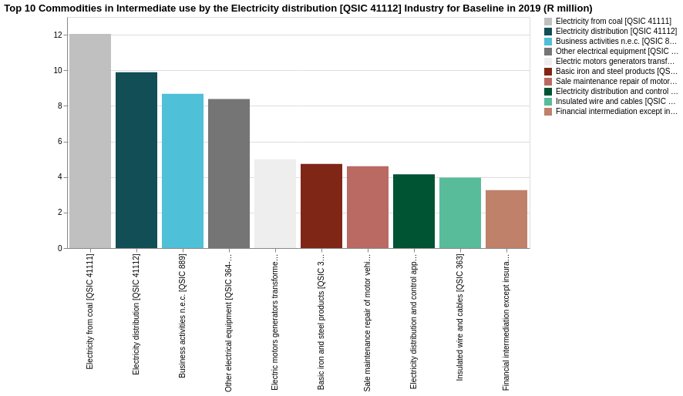

The value of intermediate use of the Electricity distribution [QSIC 41112] industry was R25,479.76 million. The commodity used most in this industry was Electricity from coal [QSIC 41111] and represented 12.05% of its own intermediate use. Other commodities that were included in the top 5 commodities were Electricity distribution [QSIC 41112] (9.89%), Business activities n.e.c. [QSIC 889] (8.68%), Other electrical equipment [QSIC 364-366] (8.38%), and Electric motors generators transformers [QSIC 361] (4.99%).

The total input of the Manufacture and distribution of gas [QSIC 412] industry was R16,156.43 million in 2019, representing 7.09% of the Electricity and gas [QSIC 41] industry's total input. The total input of the Manufacture and distribution of gas [QSIC 412] industry consisted of value-added 57.23% and intermediate use 42.75%, the rest was made up from production taxes net of production subsidies. The value-added components of the Manufacture and distribution of gas [QSIC 412] industry consisted of labour remuneration 2.68% and gross operating surplus 54.55%, the Manufacture and distribution of gas [QSIC 412] industry was relatively capital intensive.

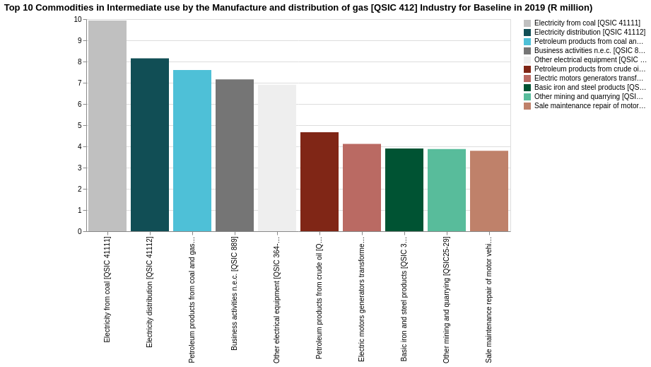

The value of intermediate use of the Manufacture and distribution of gas [QSIC 412] industry was R6,906.99 million. The commodity used most in this industry was Electricity from coal [QSIC 41111] and represented 9.93% of its own intermediate use. Other commodities that were included in the top 5 commodities were Electricity distribution [QSIC 41112] (8.15%), Petroleum products from coal and gas [QSIC 3322 and 3323] (7.60%), Business activities n.e.c. [QSIC 889] (7.16%), and Other electrical equipment [QSIC 364-366] (6.91%).

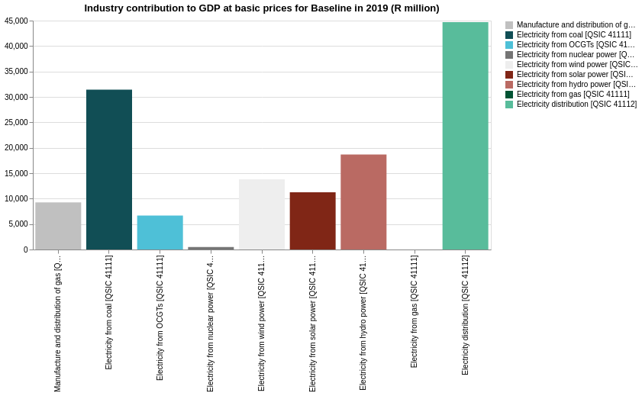

The Electricity distribution [QSIC 41112] industry contributed the most GDP at basic prices of all the industries in the Electricity and gas [QSIC 41] industry. The Electricity distribution [QSIC 41112] industry contributed 32.80% to GDP at basic prices of the Electricity and gas [QSIC 41] industry, and 0.99% to South African GDP at basic prices. The other industries' contributions to GDP at basic prices were Electricity from coal [QSIC 41111] 23.07%, Electricity from hydro power [QSIC 41111] 13.71%, Electricity from wind power [QSIC 41111] 10.13%, Electricity from solar power [QSIC 41111] 8.26%, Manufacture and distribution of gas [QSIC 412] 6.79%, Electricity from OCGTs [QSIC 41111] 4.90%, Electricity from nuclear power [QSIC 41111] 0.34%, and Electricity from gas [QSIC 41111] 0.00%.

### Output structure in SAM

The Production and distribution of electricity [QSIC 411] commodity contributed the most to total supply compared to all the commodities in the Electricity and gas [QSIC 41] commodity. The Production and distribution of electricity [QSIC 411] commodity represented 62.17% of total supply sales of the Electricity and gas [QSIC 41] commodity, and 1.15% of South African total supply sales. The other commodities' contributions to total supply were C0413365055ELECTD 30.84%, and Manufacture and distribution of gas [QSIC 412] 6.99%.

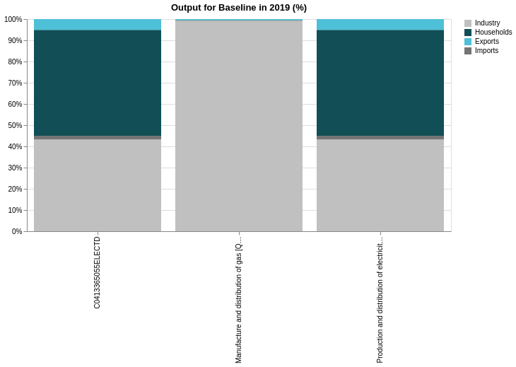

The output of the Production and distribution of electricity [QSIC 411] commodity was sold to industry (57.14%), households (48.93%), and exports (4.95%). 1.69% of output was imported.

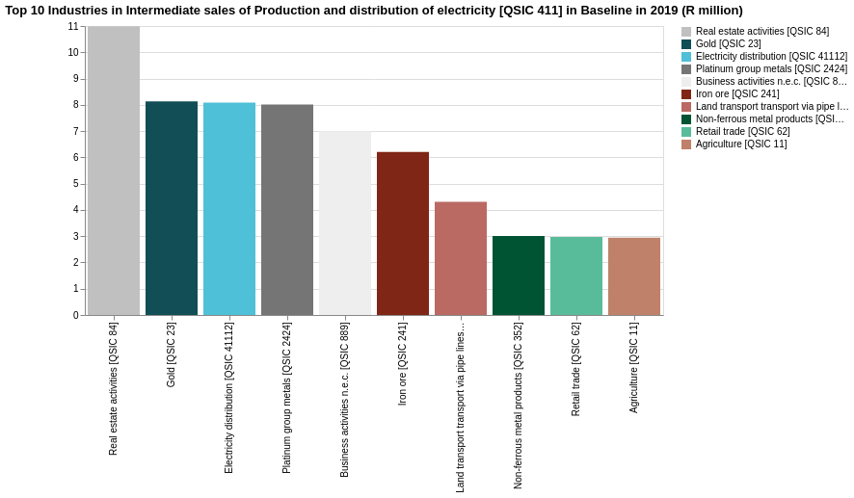

The value of intermediate sales of the Production and distribution of electricity [QSIC 411] commodity was R7,347.00 million. Output of this commodity was sold mostly to the Real estate activities [QSIC 84] industry and represented 10.99% of its total intermediate sales. Other industries that were included in the top 5 were Gold [QSIC 23] (8.13%), Electricity distribution [QSIC 41112] (8.09%), Platinum group metals [QSIC 2424] (8.01%), and Business activities n.e.c. [QSIC 889] (7.00%).

The output of the Manufacture and distribution of gas [QSIC 412] commodity was sold to industry (14.52%), households (0.11%), and exports (0.50%). 0.19% of output was imported. The value of intermediate sales of the Manufacture and distribution of gas [QSIC 412] commodity was R83.89 million. Output of this commodity was sold mostly to the Basic iron and steel products [QSIC 351] industry and represented 29.74% of its total intermediate sales. Other industries that were included in the top 5 were Basic chemicals [QSIC 334] (28.32%), Other chemical products [QSIC 335-336] (18.19%), Other fabricated metal products [QSIC 355] (3.21%), and Plastic products [QSIC 338] (2.44%).

### Contribution to employment and other concepts

Unpublished detailed employment data from Eskom was available. Eskom’s Annual Reports had sufficient information to inform on corporate taxes paid, capital stock, gross fixed capital formation and consumption of fixed capital stock values. Where available Eskom’s segmental information were used to allocate these values across the sub-industries. Personal taxes paid and the contribution to household income were calculated from the underlying labour remuneration and gross operating surplus figures.

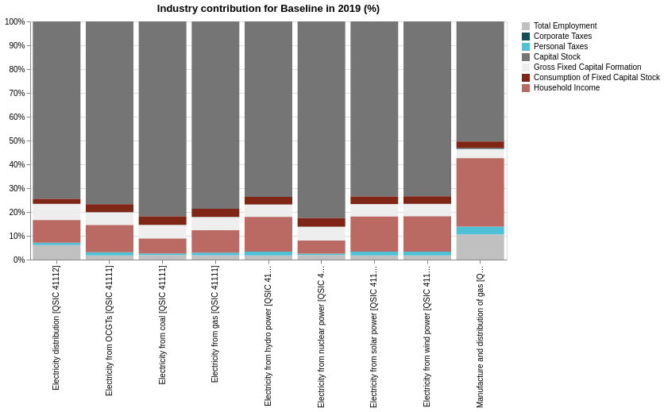

The Electricity distribution [QSIC 41112] industry contributed the most to to total employment compared to all the industries in the Electricity and gas [QSIC 41] industry. The Electricity distribution [QSIC 41112] industry contributed 59.78% to total employment of the Electricity and gas [QSIC 41] industry, and 0.19% to South African total employment. The other industries' contributions to total employment were Electricity from coal [QSIC 41111] 20.02%, Manufacture and distribution of gas [QSIC 412] 7.09%, Electricity from hydro power [QSIC 41111] 4.57%, Electricity from wind power [QSIC 41111] 3.31%, Electricity from solar power [QSIC 41111] 2.71%, Electricity from OCGTs [QSIC 41111] 2.17%, Electricity from nuclear power [QSIC 41111] 0.34%, and Electricity from gas [QSIC 41111] 0.00%.

# Summary

In 2019 the Coke petroleum products and nuclear fuel [QSIC 331-333] industry contributed 1.01% to GDP, 1.88% to output and 0.17% to employment, while the Electricity and gas [QSIC 41] industry contributed 3.01% to GDP, 2.34% to output and 0.32% to employment. Within the Coke petroleum products and nuclear fuel [QSIC 331-333] industry each sub-industry contributed as follows to GDP: Petroleum products from crude oil [QSIC 3321] (57.27%), Petroleum products from coal and gas [QSIC 3322 and 3323] (38.54%), Coke oven products [QSIC 331] (3.70%), Processing of nuclear fuel [QSIC 333] (0.50%), Petroleum product from synthesised products nec [QSIC 3329] (0.00%), and Petroleum products from organic products [QSIC 3324] (0.00%). Within the Electricity and gas [QSIC 41] industry each sub-industry contributed as follows to GDP: Electricity distribution [QSIC 41112] (32.80%), Electricity from coal [QSIC 41111] (23.07%), Electricity from hydro power [QSIC 41111] (13.71%), Electricity from wind power [QSIC 41111] (10.13%), Electricity from solar power [QSIC 41111] (8.26%), and Manufacture and distribution of gas [QSIC 412] (6.79%). Electricity from OCGTs [QSIC 41111] (4.90%), Electricity from nuclear power [QSIC 41111] (0.34%), Electricity from nuclear power [QSIC 41111] (0.34%), Within the Coke petroleum products and nuclear fuel [QSIC 331-333] industry the Petroleum products from crude oil [QSIC 3321] industry had the largest output and the largest employment, representing (60.54%) and (63.25%) of the industry's output and employment, respectively. Within the Electricity and gas [QSIC 41] industry the Electricity from coal [QSIC 41111] industry had the largest output and Electricity distribution [QSIC 41112] industry the largest employment, representing (37.53%) and (59.78%) of the industry's output and employment, respectively.

# Appendix A – List of Industries and Commodities, and Labour Categories

## Industries

| **Industries and Commodities** | | | |
| --- | --- | --- | --- |
| 1 | Agriculture [QSIC 11] | 41 | Glass and glass products [QSIC 341] |
| 2 | Forestry [QSIC 12] | 42 | Non-metallic mineral products [QSIC 342] |
| 3 | Fishing [QSIC 13] | 43 | Basic iron and steel products [QSIC 351] |
| 4 | Coal [QSIC 21] | 44 | Non-ferrous metal products [QSIC 352] |
| 5 | Gold [QSIC 23] | 45 | Structural metal products [QSIC 354] |
| 6 | Iron ore [QSIC 241] | 46 | Other fabricated metal products [QSIC 355] |
| 7 | Chrome [QSIC 2421] | 47 | General purpose machinery [QSIC 356] |
| 8 | Copper [QSIC 2422] | 48 | Special purpose machinery [QSIC 357] |
| 9 | Manganese ore [QSIC 2423] | 49 | Household appliances [QSIC 358] |
| 10 | Platinum group metals [QSIC 2424] | 50 | Office, accounting, computing machinery [QSIC 359] |
| 11 | Other metallic minerals [QSIC 2429] | 51 | Electric motors, generators, transformers [QSIC 361] |
| 12 | Natural gas [QSIC 22] | 52 | Electricity distribution and control apparatus [QSIC 362] |
| 13 | Crude petroleum [QSIC 22] | 53 | Insulated wire and cables [QSIC 363] |
| 14 | Other mining and quarrying [QSIC25-29] | 54 | Other electrical equipment [QSIC 364-366] |
| 15 | Meat, fish, fruit etc. [QSIC 301] | 55 | Radio, television and communication apparatus [QSIC 371-373] |
| 16 | Dairy products [QSIC 302] | 56 | Professional equipment [QSIC 374-376] |
| 17 | Grain mill products [QSIC 303] | 57 | Motor vehicles [QSIC 381-382] |
| 18 | Other food products [QSIC 304] | 58 | Parts and accessories [QSIC 383] |
| 19 | Beverages [QSIC 305] | 59 | Other transport equipment [QSIC 384-387] |
| 20 | Tobacco [QSIC 306] | 60 | Furniture [QSIC 391] |
| 21 | Textiles [QSIC 311] | 61 | Other manufacturing groups [QSIC 392-395] |
| 22 | Other textile products [QSIC 312] | 62 | Electricity from coal generation [QSIC 411] |
| 23 | Knitted, crocheted articles [QSIC 313] | 63 | Electricity from gas [QSIC 411] |
| 24 | Wearing apparel [QSIC 314] | 64 | Nuclear energy [QSIC 411] |
| 25 | Leather and leather and fur products [QSIC 315-316] | 65 | Wind energy [QSIC 411] |
| 26 | Footwear [QSIC 317] | 66 | Solar energy [QSIC 411] |
| 27 | Sawmilling and planing of wood [QSIC 321] | 67 | Hydro energy [QSIC 411] |
| 28 | Products of wood [QSIC 322] | 68 | Gas [QSIC 412] |
| 29 | Paper and paper products [QSIC 323] | 69 | Water [QSIC 42] |
| 30 | Printing, recorded media [QSIC 324-326] | 70 | Site preparation [QSIC 501] |
| 31 | Coke [QSIC 331] | 71 | Building of complete constructions [QSIC 502] |
| 32 | Conventional refineries (OTL) [QSIC 3321] | 72 | Building installation [QSIC 503] |
| 33 | Conventional synfuels (CTL and GTL) [QSIC 3322-3323] | 73 | Building completion [QSIC 504] |
| 34 | Bio-fuels [QSIC 3324] | 74 | Renting of construction equipment [QSIC 505] |
| 35 | Green synfuels (Green H2) [QSIC 3325,3329] | 75 | Wholesale trade, commission trade [QSIC 61] |
| 36 | Nuclear fuel [QSIC 333] | 76 | Retail trade [QSIC 62] |
| 37 | Basic chemicals [QSIC 334] | 77 | Sale, maintenance, repair of motor vehicles [QSIC 63] |
| 38 | Other chemical products [QSIC 335-336] | 78 | Catering and accommodation services [QSIC 64] |
| 39 | Rubber products [QSIC 337] | 79 | Land transport, transport via pipe lines [QSIC 71] |
| 40 | Plastic products [QSIC 338] | 80 | Water transport [QSIC 72] |
| 81 | Air transport [QSIC 73] | 93 | Architectural, engineering and other technical activities [QSIC 882] |
| 82 | Auxiliary transport [QSIC 74] | 94 | Advertising [QSIC 883] |
| 83 | Postal and related courier activities [QSIC 751] | 95 | Business activities nec [QSIC 889] |
| 84 | Telecommunication [QSIC 752] | 96 | National departments [QSIC 91101] |
| 85 | Financial intermediation except insurance and pension funding [QSIC 81] | 97 | Provincial departments [QSIC 91102] |
| 86 | Insurance and pension funding [QSIC 82] | 98 | Local government [QSIC 91300] |
| 87 | Activities auxiliary to financial intermediation [QSIC 83] | 99 | Education [QSIC 92] |
| 88 | Real estate activities [QSIC 84] | 100 | Health and social work [QSIC 93] |
| 89 | Renting of machinery and equipment, without operator and of personal and household goods [QSIC 85] | 101 | Sewerage, refuse, sanitation [QSIC 94] |
| 90 | Computer and related activities [QSIC 86] | 102 | Membership activities [QSIC 95] |
| 91 | Research and development [QSIC 87] | 103 | Recreation, cultural, sport activities [QSIC 96] |
| 92 | Legal, accounting, bookkeeping and auditing activities [QSIC 881] | 104 | Other activities [QSIC 99] |

## List of labour categories

|  |  |
| --- | --- |
| **Description** | **Occupational categories** |
| Formal: Highly skilled labour | Professional, semi-professional and technical occupations |
|  | Managerial, executive, and administrative occupations |
|  | Certain transport occupations, for example a pilot navigator |
| Formal: Skilled labour | Clerical occupations |
|  | Sales occupations |
|  | Transport, delivery, and communications occupations |
|  | Service occupations |
|  | Farmer, farm manager |
|  | Artisan, apprentice, and related occupations |
|  | Production foreman, production supervisor |
| Formal: Semi- and unskilled labour | All other formal sector occupations |
| Informal labour |  |

# Appendix B – Data sources used

|  |  |
| --- | --- |
| Source | Description |
| SARB | National accounts data  Public financial statistics  Production, distribution, and accumulation accounts |
| Stats SA | National accounts data  GDP data  Supply and use tables  Social Accounting Matrices  Annual Financial Statistics  Labour Force Survey (LFS)  Quarterly Labour Force Survey (QFLS)  Quarterly Survey of Employers (QES)  Household Survey (HS)  Population Census  Community Survey  Living Conditions Survey (LCS) |
| SARS | Trade statistics  Tax statistics |
| National Treasury | Estimates of Government Revenue and Expenditure Statistics  Tax statistics |
| Department of Energy | Consolidated, Aggregated and Historical Energy Balances per commodity. |
| Sasol Ltd | Annual Financial Statements for 2020.  Integrated Report for 2020.  Sustainability Report for 2020.  Unpublished employment data. |
| PetroSA SOC Ltd | Integrated Report for 2019. |
| Eskom SOC Ltd | Annual Financial Statements for 2020.  Integrated Report for 2020.  Unpublished employment data. |

# Appendix C – SIC classification

Stats SA. Standard Industrial Classification of all economic activities (Fifth Ed) as published in 1970. This edition is based on the third revision of the International Standard Industrial Classification of all Economic Activities (ISIC) as published by the United Nations.

## SIC: Extraction of crude petroleum and natural gas [QSIC 221]

Extraction of crude petroleum oils and bituminous minerals, including the processes in order to obtain crude oils. The production of natural gas. The liquefaction and regasification of natural gas for purposes of transport.

## SIC: Other mining and quarrying [QSIC 25-29]

This includes the mining of diamonds, the mining of chemical and fertilizer minerals, the extraction and evaporation of salt, the mining of precious and semi-precious stones, asbestos, other mining and quarrying materials such as corundum, andalusite, etc as well as service activities incidental to mining of minerals such as the removal of coal by sub-contractors.

## SIC: Manufacture of Coke Oven Products [QSIC 331]

Operation of coke ovens for the production of coke or semi-coke from hard coal or lignite, or retort carbon and residual products such as coal tar or pitch. The agglomeration of coke. The manufacture of asphalt material for road building and other purposes; fuel and igniting briquettes and packaged fuel from purchased coal or lignite.

## Petroleum refineries or synthesisers [QSIC 332]

Production of liquid or gaseous fuels, illuminating oils, lubricating oils or greases or other products from crude petroleum or bituminous minerals or their fractionation products. Manufacture or extraction of products such as petroleum jelly, paraffin was, other petroleum waxes and residual products such as petroleum coke, petroleum bitumen etc. Manufacture of compounded and blended lubricating oils and greases from purchased materials other than crude petroleum and oil. Manufacture of lubricating oils and greases primarily from other organize materials.

## Nuclear fuels [QSIC 333]

This SIC code includes the extraction of uranium metal from pitchblende and or uranium blending ores, the manufacture of alloys, dispersion of mixtures of natural uranium or its compounds, the manufacture of enriched uranium and its compounds, plutonium and its compounds; or alloys; dispersions or mixtures of these compounds, the manufacture of uranium depleted in U 235 and its compounds, thorium and its compounds; or alloys, dispersions or mixtures of these compounds, the manufacture of other radioactive elements, isotopes or compounds, and the manufacture of non-irradiated fuel element for use in nuclear reactors.

## Electricity [QSIC 411]

Includes the generation, transmission and distribution of electric energy for sale to households, industrial and commercial users. Electricity may be generated conventionally, hydraulically, thermally, geothermally or by means of solar energy, nuclear energy or tidal energy. Included are electric power plants which, as ancillary divisions of establishments generate electricity for use by such establishments.

## Gas [QSIC 412]

Manufacture of gaseous fuels in gasworks. Production of gas by the carbonation of coal or by mixing manufactured gas with natural gas or petroleum or other gases. The distribution of gaseous fuels through a system of mains to household, industrial, commercial or other users. Exclusions include pipelines and bottled industrial gases.

1. United Nations. 2008. System of National Accounts 2008. <https://unstats.un.org/unsd/nationalaccount/sna.asp>
2. Löfgren, H., R.L. Harris and S. Robinson. 2002. A standard computable general equilibrium (CGE) model in GAMS. <https://www.ifpri.org/publication/standard-computable-general-equilibrium-cge-model-gams-0>
3. The biofuels industry does not exist in the economy in 2019. It will grow as the economy move towards 2050. For now, it is included as a negligible small industry.
4. The green synfuels industry also does not exist in the economy in 2019. It will grow as the economy move towards 2050. For now, it is included as a negligible small industry.
5. The electricity from gas industry does not exist in 2019. It is expected to grow as the economy moves to 2050. For now, it is included, but negligible small.